Day 21 26th July 2025

SOLID:

S -
O -
L -
I -
D -

Liskov Substitution Principle

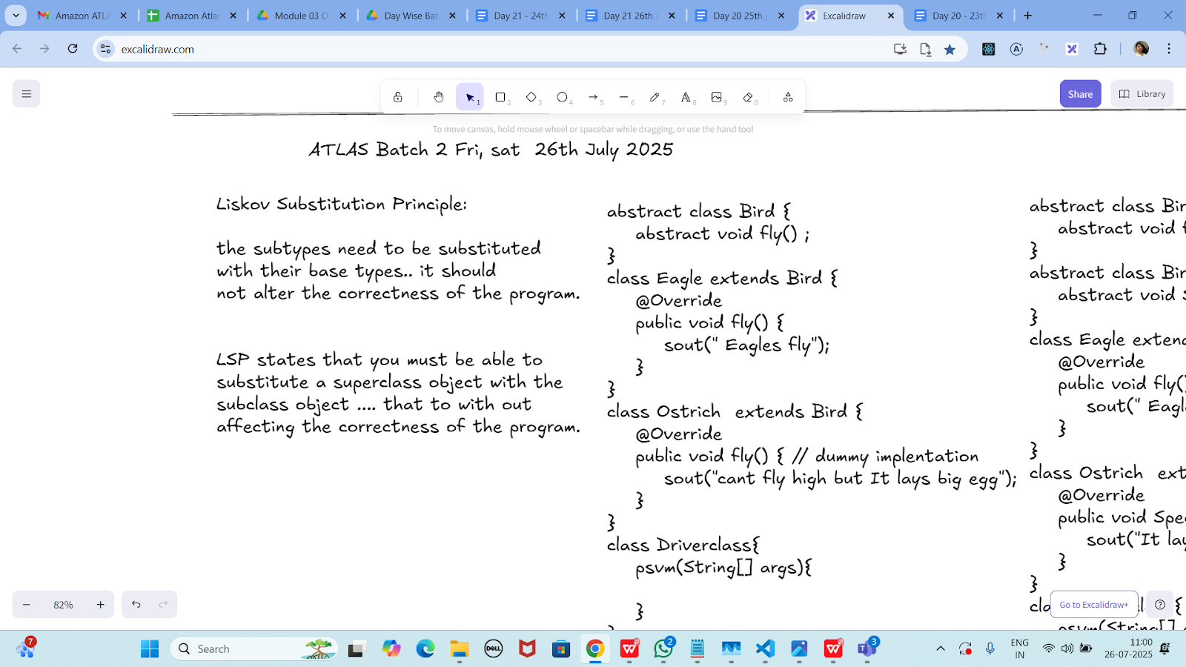

Task 01:

Violation of Liskov

abstract class Bird {
abstract void fly() ;
}
class Eagle extends Bird {
@Override
public void fly() {
sout(" Eagles fly");
}
}
class Ostrich extends Bird {
@Override
public void fly() { // dummy implentation
sout("cant fly high but It lays big egg");
}
}
class Driverclass{
psvm(String[] args){

}
}
abstract class Bird {
abstract void fly();
}

class Eagle extends Bird {
@Override
public void fly() {
System.out.println("Eagle flies high in the sky.");
}
}

class Ostrich extends Bird {
@Override
public void fly() {
// Violation: Ostrich can't fly
System.out.println("Ostrich can't really fly, but this method is here just to satisfy the abstract method.");
}
}

public class BirdLSPViolation {
public static void main(String[] args) {
Bird b1 = new Eagle();
Bird b2 = new Ostrich();

b1.fly(); // OK
b2.fly(); // Logically incorrect - misleading behavior
}
}
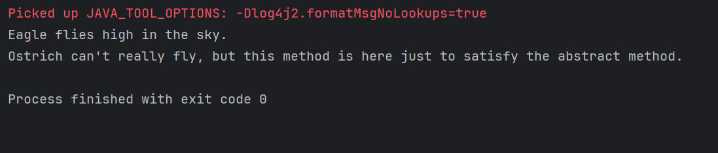

Task 02:

Implementation of Liskov

abstract class BirdsthatFly {
abstract void fly() ;
}
abstract class BirdsthatDontFly {
abstract void Speciality() ;
}
class Eagle extends BirdsthatFly {
@Override
public void fly() {
sout(" Eagles fly");
}
}
class Ostrich extends BirdsthatDontFly {
@Override
public void Speciality() {
sout("It lays big egg");
}
}
class Driverclass{
psvm(String[] args){

}
}
abstract class Bird {
abstract void fly();
}

class Eagle2 extends Bird {
@Override
public void fly() {
System.out.println("Eagle2 flies high in the sky.");
}
}

class Ostrich2 extends Bird {
@Override
public void fly() {
// Violation: Ostrich2 can't fly
System.out.println("Ostrich2 can't really fly, but this method is here just to satisfy the abstract method.");
}
}

public class BirdLSPViolation {
public static void main(String[] args) {
Bird b1 = new Eagle2();
Bird b2 = new Ostrich2();

b1.fly(); // OK
b2.fly(); // Logically incorrect - misleading behavior
}
}
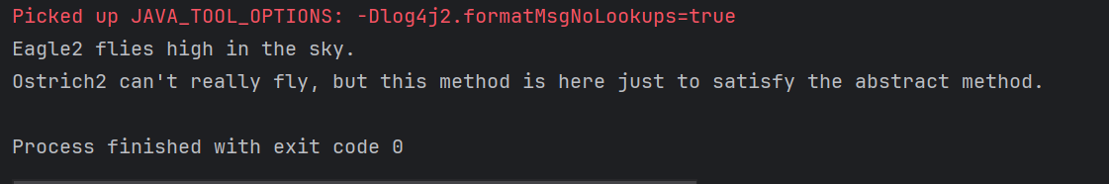

I - Interface Segregation Principle

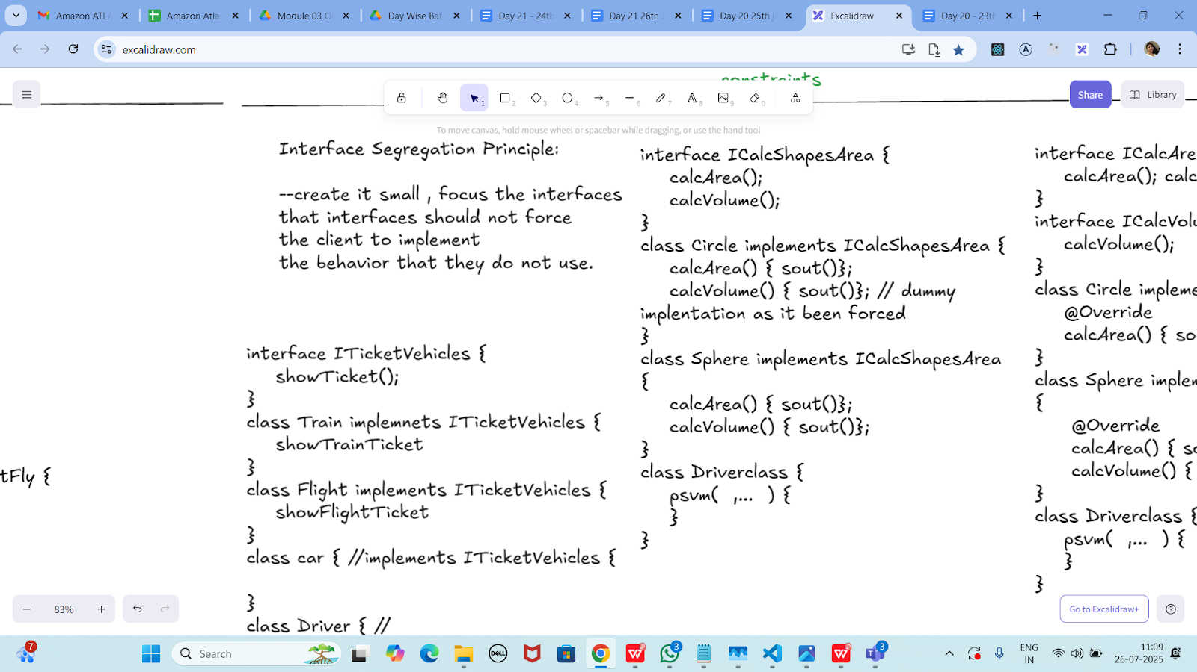

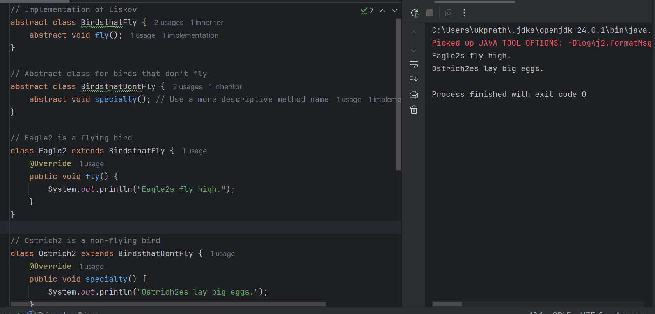
Task 03:
Violation of Interface Segregation principle

interface ICalcShapesArea {
calcArea();
calcVolume();
}
class Circle implements ICalcShapesArea {
calcArea() { sout()};
calcVolume() { sout()}; // dummy implentation as it been forced
}
class Sphere implements ICalcShapesArea {
calcArea() { sout()};
calcVolume() { sout()};
}
class Driverclass {
psvm( ,... ) {
}
}
interface ICalcShapesArea {
void calcArea();
void calcVolume(); // Problem: Not all shapes have volume
}

class Circle implements ICalcShapesArea {
@Override
public void calcArea() {
System.out.println("Calculating area of Circle...");
}

@Override
public void calcVolume() {
// ISP Violation: Circle has no volume, but must implement this
System.out.println("Circle has no volume! (dummy method)");
}
}

class Sphere implements ICalcShapesArea {
@Override
public void calcArea() {
System.out.println("Calculating surface area of Sphere...");
}

@Override
public void calcVolume() {
System.out.println("Calculating volume of Sphere...");
}
}

public class DriverClass2 {
public static void main(String[] args) {
ICalcShapesArea circle = new Circle();
circle.calcArea();
circle.calcVolume(); // Unnecessary and misleading

ICalcShapesArea sphere = new Sphere();
sphere.calcArea();
sphere.calcVolume();
}
}
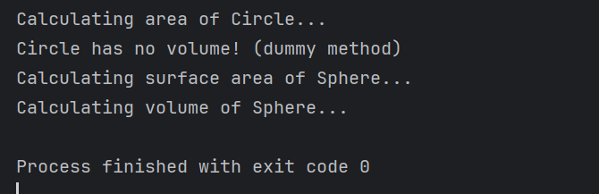
Task 04:
Implementation of Interface Segregation Principle

interface ICalcArea {
calcArea(); calcPerimeter();
}
interface ICalcVolume {
calcVolume();
}
class Circle implements ICalcArea {
@Override
calcArea() { sout()};
}
class Sphere implements ICalcArea, ICalcVolume {
@Override
calcArea() { sout()};
calcVolume() { sout()};
}
class Driverclass {
psvm( ,... ) {
}
}
// Interface for shapes that have area and perimeter (2D shapes)
interface ICalcArea {
void calcArea();
void calcPerimeter();
}

// Interface for shapes that have volume (3D shapes)
interface ICalcVolume {
void calcVolume();
}

// Circle is a 2D shape: only implements ICalcArea
class Circle implements ICalcArea {
@Override
public void calcArea() {
System.out.println("Calculating area of Circle...");
}

@Override
public void calcPerimeter() {
System.out.println("Calculating perimeter of Circle...");
}
}

// Sphere3 is a 3D shape: implements both ICalcArea and ICalcVolume
class Sphere3 implements ICalcArea, ICalcVolume {
@Override
public void calcArea() {
System.out.println("Calculating surface area of Sphere3...");
}

@Override
public void calcPerimeter() {
System.out.println("Calculating circular cross-section perimeter...");
}

@Override
public void calcVolume() {
System.out.println("Calculating volume of Sphere3...");
}
}

public class DriverClass3 {
public static void main(String[] args) {
ICalcArea circle = new Circle();
circle.calcArea();
circle.calcPerimeter();

Sphere3 Sphere3 = new Sphere3();
Sphere3.calcArea();
Sphere3.calcPerimeter();
Sphere3.calcVolume();
}
}
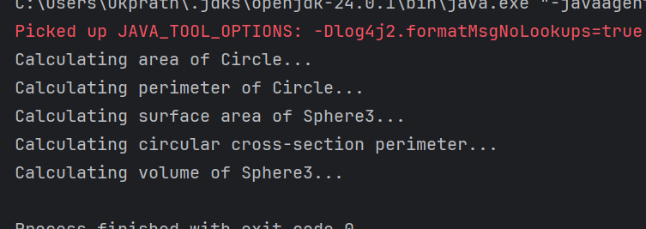

Dependency Inversion Principle:

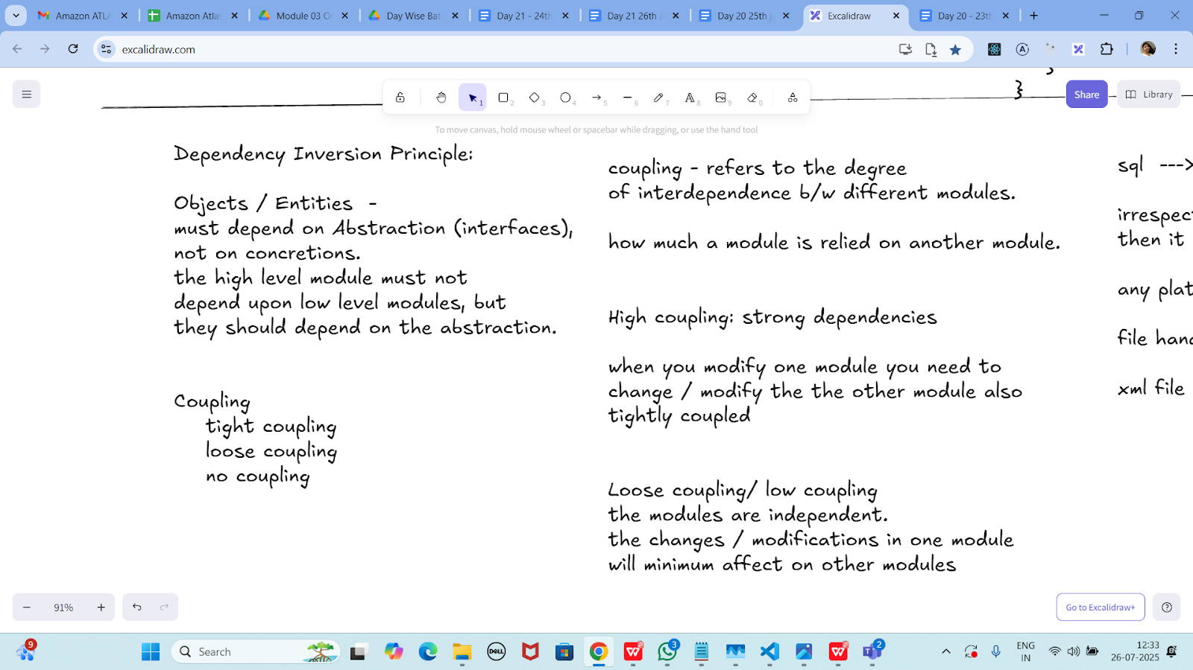

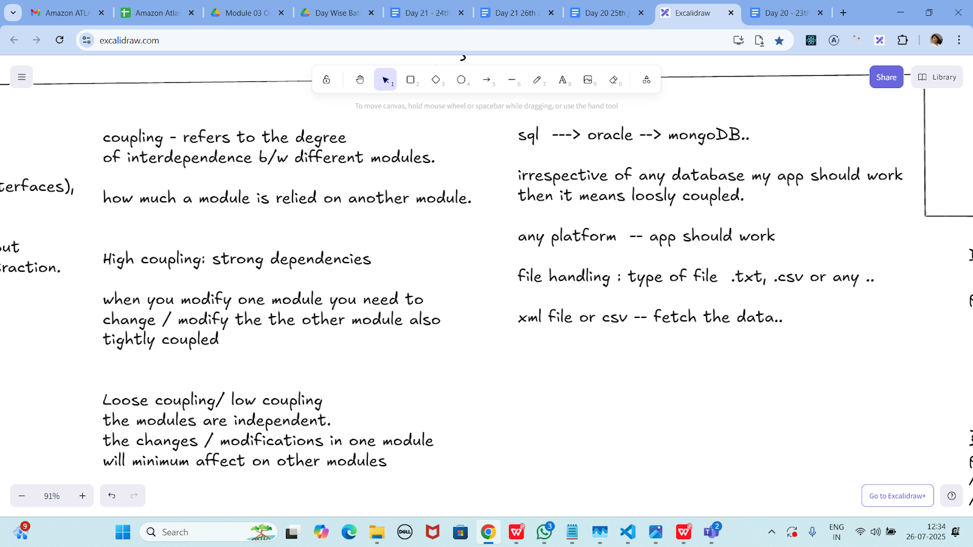

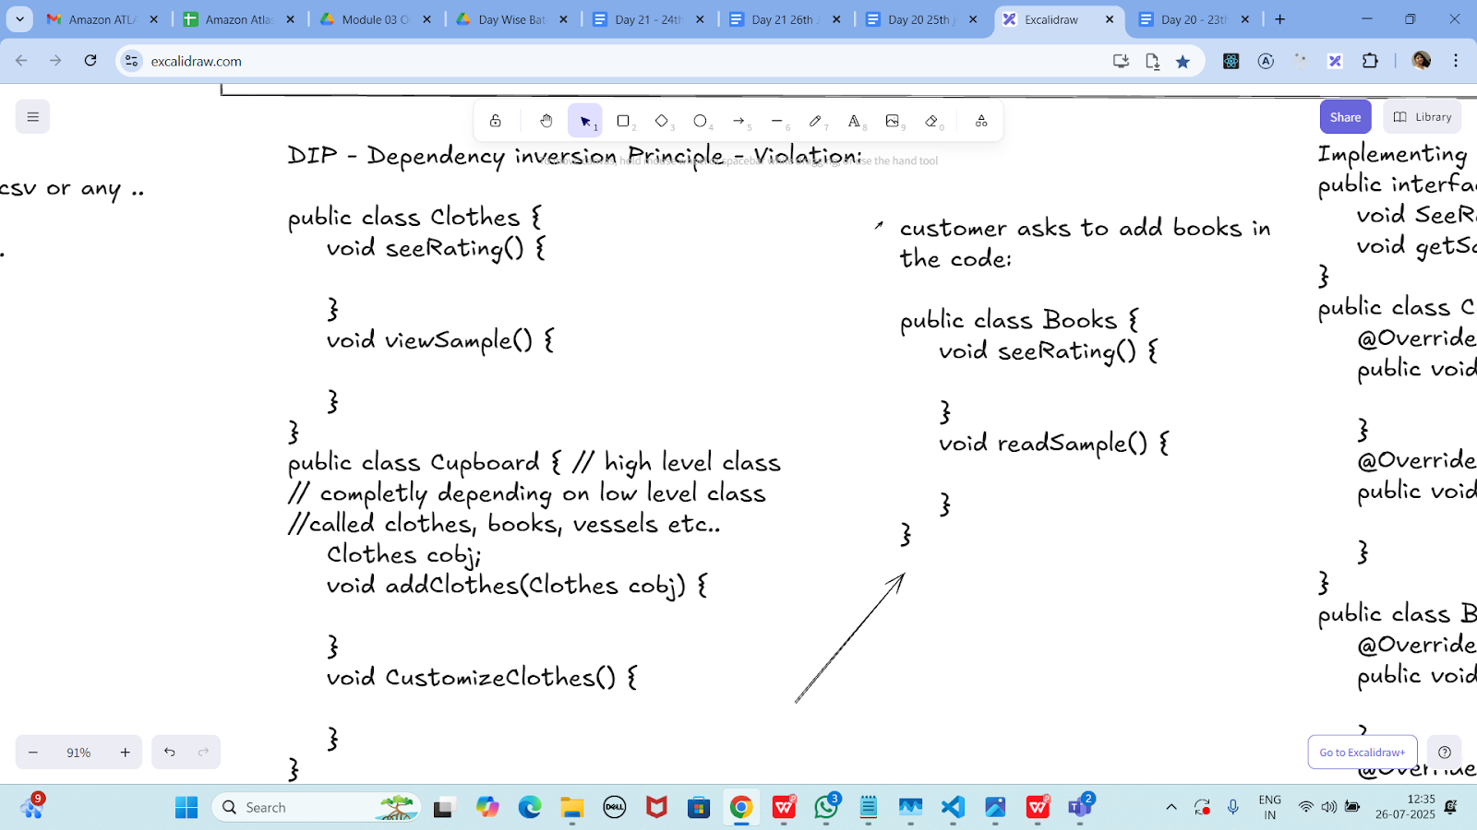

Dip violation code:

DIP - Dependency inversion Principle - Violation:

public class Clothes {
void seeRating() {

}
void viewSample() {

}
}
public class Cupboard { // high level class
// completly depending on low level class
//called clothes, books, vessels etc..
Clothes cobj;
void addClothes(Clothes cobj) {

}
void CustomizeClothes() {

}
}

customer asks to add books in the code:

public class Books {
void seeRating() {

}
void readSample() {

}
}

// Low-level module
class Clothes {
void seeRating() {
System.out.println("Clothes rating shown");
}

void viewSample() {
System.out.println("Viewing clothes sample");
}
}

// Another low-level module (new customer request)
class Books {
void seeRating() {
System.out.println("Book rating shown");
}

void readSample() {
System.out.println("Reading book sample");
}
}

// High-level module that violates DIP
class Cupboard {
Clothes cobj;
Books bobj;

void addClothes(Clothes cobj) {
this.cobj = cobj;
}

void addBooks(Books bobj) {
this.bobj = bobj;
}

void customizeClothes() {
System.out.println("Customizing clothes:");
cobj.viewSample();
cobj.seeRating();
}

void customizeBooks() {
System.out.println("Customizing books:");
bobj.readSample();
bobj.seeRating();
}
}

// Main class with main method
public class DriverClass4 {
public static void main(String[] args) {
Cupboard cupboard = new Cupboard();

// Adding and customizing clothes
Clothes clothes = new Clothes();
cupboard.addClothes(clothes);
cupboard.customizeClothes();

// Adding and customizing books
Books books = new Books();
cupboard.addBooks(books);
cupboard.customizeBooks();
}
}
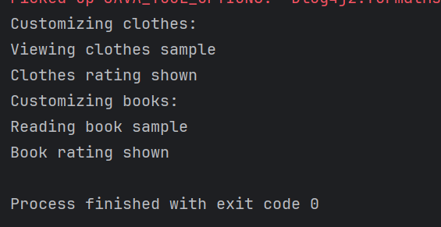
Now DIP implementation:

Implementing Dependency Inversion Principle
public interface IProduct {
void SeeReviews();
void getSample();
}
public class Clothes implements IProduct {
@Override
public void SeeReviews() {

}
@Override
public void getSample() {

}
}
public class Books implements IProduct {
@Override
public void SeeReviews() {

}
@Override
public void getSample() {

}
}

interface IProduct {
void seeReviews();
void getSample();
}

class Clothes2 implements IProduct {
@Override
public void seeReviews() {
System.out.println("Showing reviews for Clothes2...");
}

@Override
public void getSample() {
System.out.println("Showing Clothes2 sample...");
}
}

class Books implements IProduct {
@Override
public void seeReviews() {
System.out.println("Showing reviews for Books...");
}

@Override
public void getSample() {
System.out.println("Reading book sample...");
}
}

class Cupboard2 {
private IProduct product;

public void addProduct(IProduct product) {
this.product = product;
}

public void customizeProduct() {
product.getSample();
product.seeReviews();
}
}

public class DriverClass5 {
public static void main(String[] args) {
Cupboard2 Cupboard2 = new Cupboard2();

IProduct Clothes2 = new Clothes2();
Cupboard2.addProduct(Clothes2);
System.out.println("=== Clothes2 ===");
Cupboard2.customizeProduct();

IProduct books = new Books();
Cupboard2.addProduct(books);
System.out.println("=== Books ===");
Cupboard2.customizeProduct();
}
}
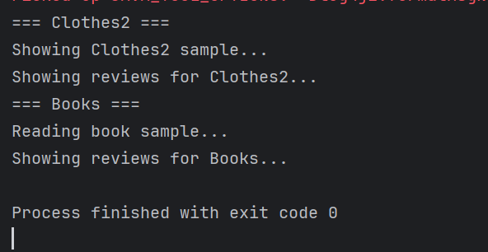

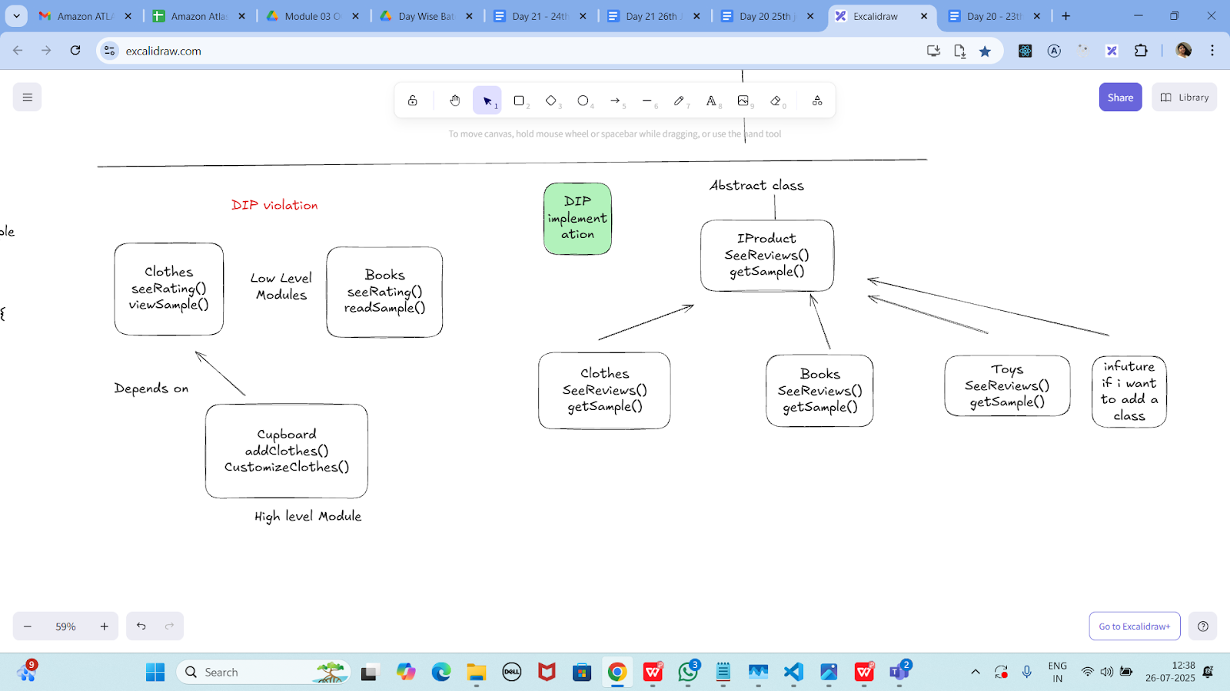

================================================================================================================================================
Home Tasks:
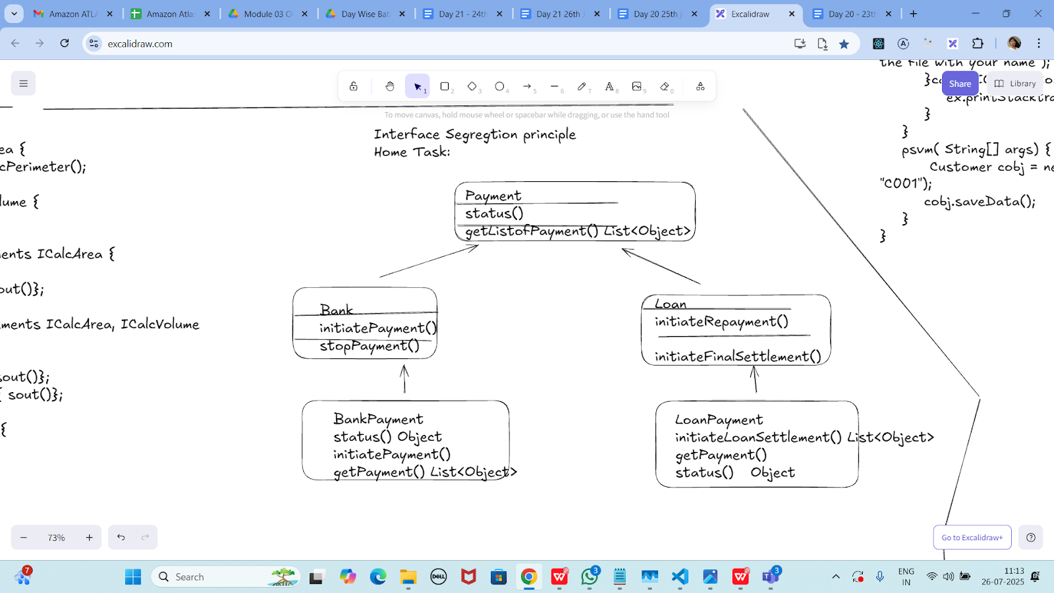

Task 02:
class Animal {
void sound() {
sout(" sounds of different animals");
}
}
class Cat extends Animal{
@Override
void sound() {
sout(" Meow is the sound of cat");
}
}
class Main{
psvm(String[] args) {
Animal obj = new Cat();
obj.sound(); //Meow is the sound of cat
}
}
issue with Substitution and Generics

Java Generics -- it has introduced a challenge - substitution principle...

is cat a subtype of Animal, List<cat> is not a subtype of List<Animal>

List<Cat> Cobj = new ArrayList<>();
List<Animal> Aobj = Cobj; ===// this will give you a wildcard ,

wildcards:

1. unbounded Wildcard
? ===> any data type if you want to use you can use ?

2. Bounded Wildcards with an upper bound (? extends Type)

===> yopu will use it when you need to accept a type and its own subtypes

3. Bounded Wildcards with an lower bound (? super Type)
===> you will use when ypou need accept a type and its super types

import java.util.ArrayList;
import java.util.List;

class Animal {
void sound() {
System.out.println("Sounds of different animals");
}
}

class Cat extends Animal {
@Override
void sound() {
System.out.println("Meow is the sound of cat");
}
}

public class hometask01 {
public static void main(String[] args) {
// Invariance: List<Cat> is NOT a subtype of List<Animal>
List<Cat> catList = new ArrayList<>();
catList.add(new Cat());

// List<Animal> animals = catList; // Compile Error!

// Using unbounded wildcard
List<?> unknownList = catList;
Object obj = unknownList.get(0); // Allowed
System.out.println("Object from unknownList: " + obj.getClass().getSimpleName());

// Using upper bounded wildcard: List of unknown subtype of Animal
List<? extends Animal> animalsExtends = catList;
Animal a = animalsExtends.get(0); // Allowed to read as Animal
a.sound();
// animalsExtends.add(new Cat()); // Compile Error: can't add

// Using lower bounded wildcard: List of some supertype of Cat
List<? super Cat> animalsSuper = new ArrayList<Animal>();
animalsSuper.add(new Cat()); // Allowed to add Cat
// Animal an = animalsSuper.get(0); // Compile Error: can't safely read as Animal
Object o = animalsSuper.get(0); // Can read as Object
System.out.println("Object from animalsSuper: " + o);
}
}

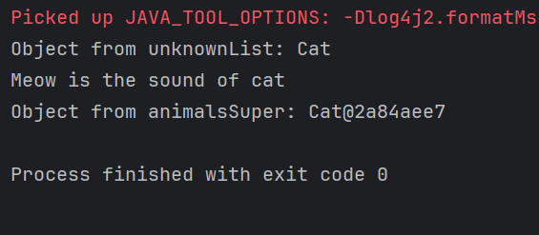

Unbounded wildcards:
Task 03:
they are useful when the code does not depends on the actual type parmeter

void printList(List<?> list) {
for(Object element: list) {
sout (element);
}
}

List<Cat> clist = new ArrayList<>();
clist.add(new Cat());
printList(clist); //

import java.util.ArrayList;
import java.util.List;

class Animal1 {
@Override
public String toString() {
return "Animal1";
}
}

class Cat1 extends Animal1 {
@Override
public String toString() {
return "Cat1";
}
}

public class hometask02 {
// Method that accepts a list of any type using unbounded wildcard
static void printList(List<?> list) {
for (Object element : list) {
System.out.println(element);
}
}

public static void main(String[] args) {
List<Cat1> Cat1List = new ArrayList<>();
Cat1List.add(new Cat1());

printList(Cat1List); // Prints: Cat1
}
}
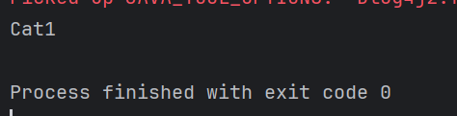

---------------------------
Task 04:

Upper Bounded Wildcards

void animalSound(List<? extends Animal> animalList) {
for(Animal elements : animalList
elements.sound();
}
}
List<Cat> cats = new ArrayList<>();
cats.add(new Cat());
animalSound(cats); //meow
import java.util.ArrayList;
import java.util.List;

class Animal3 {
void sound() {
System.out.println("Sounds of different Animal3s");
}
}

class Cat3 extends Animal3 {
@Override
void sound() {
System.out.println("Meow is the sound of Cat3");
}
}

public class hometask01 {
public static void main(String[] args) {
// Invariance: List<Cat3> is NOT a subtype of List<Animal3>
List<Cat3> Cat3List = new ArrayList<>();
Cat3List.add(new Cat3());

// List<Animal3> Animal3s = Cat3List; // Compile Error!

// Using unbounded wildcard
List<?> unknownList = Cat3List;
Object obj = unknownList.get(0); // Allowed
System.out.println("Object from unknownList: " + obj.getClass().getSimpleName());

// Using upper bounded wildcard: List of unknown subtype of Animal3
List<? extends Animal3> Animal3sExtends = Cat3List;
Animal3 a = Animal3sExtends.get(0); // Allowed to read as Animal3
a.sound();
// Animal3sExtends.add(new Cat3()); // Compile Error: can't add

// Using lower bounded wildcard: List of some supertype of Cat3
List<? super Cat3> Animal3sSuper = new ArrayList<Animal3>();
Animal3sSuper.add(new Cat3()); // Allowed to add Cat3
// Animal3 an = Animal3sSuper.get(0); // Compile Error: can't safely read as Animal3
Object o = Animal3sSuper.get(0); // Can read as Object
System.out.println("Object from Animal3sSuper: " + o);
}
}

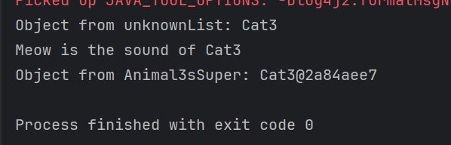
----------------------------
Task 05:

lower Bounded Wildcards

void addAcat(List<? super Cat> cats) {
cats.add(new Cat());
}
List<Animal> animals = new ArrayList<>();
addAcat(animals); //

import java.util.ArrayList;
import java.util.List;

class Animal4 {
void sound() {
System.out.println("Animal4 makes a sound");
}
}

class Cat4 extends Animal4 {
@Override
void sound() {
System.out.println("Meow is the sound of Cat4");
}
}

public class hometask04 {
// Lower bounded wildcard: accepts Cat4 or any superclass (Animal4, Object)
static void addACat4(List<? super Cat4> Cat4s) {
Cat4s.add(new Cat4()); // ✅ Safe to add
System.out.println("Cat4 added to the list.");
}

public static void main(String[] args) {
List<Animal4> Animal4s = new ArrayList<>();
addACat4(Animal4s); // ✅ Works because Animal4 is a supertype of Cat4

// Show what's inside the list
for (Animal4 Animal4 : Animal4s) {
Animal4.sound(); // Output: Meow is the sound of Cat4
}

// Also works with List<Object>
List<Object> objects = new ArrayList<>();
addACat4(objects); // ✅ Still valid: Object is a supertype of Cat4
}
}
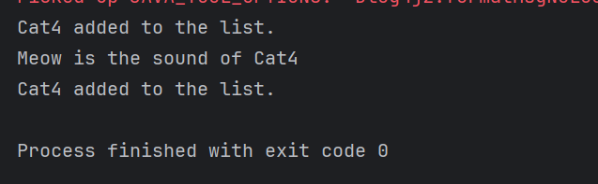
—----------------------------

Task 06:

class Student {
public int roll_no = 10;
//private int roll_no = 10;
public int getRoll() {
System.out.println("getRoll method");
return roll_no;
}
public void setRoll(int roll) {
if(!(roll > 100))
roll_no = roll;
}
}
class Tight_Coupling01 {
public static void main(String[] args) {
Student sobj = new Student();
sobj.roll_no = 10;
//sobj.roll_no = 110;
System.out.println("the roll no of student is "+ sobj.roll_no); // 110
}
}

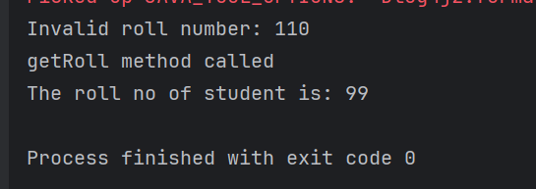
Task 07:

// loose coupling

class Student {
private int roll_no = 0;
public int getRoll() {
sout("getRoll method");
return roll_no;
}
public void setRoll(int roll) {
if(!(roll > 100)
roll_no = roll;
}
}
class Loose_coupling {
psvm(String....) {
Student sobj = new Student();// Person pobj = new Student(); // person got a bonus
sobj.setRoll(10);
sout("the roll no of student is "+ sobj.getroll();
}
}
class Student2 {
private int roll_no = 0;

public int getRoll() {
System.out.println("getRoll method");
return roll_no;
}

public void setRoll(int roll) {
if (!(roll > 100)) {
roll_no = roll;
} else {
System.out.println("Invalid roll number: " + roll);
}
}
}

public class Loose_Coupling {
public static void main(String[] args) {
Student2 sobj = new Student2(); // Could also be: Person pobj = new Student2(); (with an interface)

sobj.setRoll(10); // Valid roll number
System.out.println("The roll no of Student2 is " + sobj.getRoll());
}
}

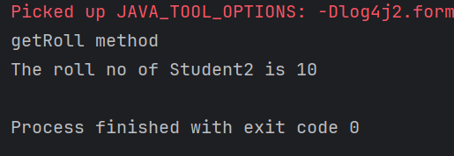
Task 08:

DIP - violation:

class LightBulb {
void turnOn() {
sout("light turned on");
}
void turnOff() {
sout("light is off");
}
}
class Switch { // switch class directly depends on the lightbulb class ---- DIP violating
LightBulb lbulbobj;
Switch(LightBulb lbulbobj) {
this.lbulbobj = lbulbobj;
}
void operates(){
lbulbobj.turnOn();
}
psvm(....){
LightBulb lbulbobj = new lightBulb();
Switch Switchobj = new Switch(lbulbobj);
Switchobj.operate();
}
}
class LightBulb {
void turnOn() {
System.out.println("Light turned on");
}

void turnOff() {
System.out.println("Light is off");
}
}

// DIP Violation: Switch directly depends on LightBulb
class Switch {
LightBulb lbulbobj;

Switch(LightBulb lbulbobj) {
this.lbulbobj = lbulbobj;
}

void operate() {
lbulbobj.turnOn();
}

public static void main(String[] args) {
LightBulb lbulbobj = new LightBulb(); // tightly coupled
Switch switchObj = new Switch(lbulbobj);
switchObj.operate();
}
}
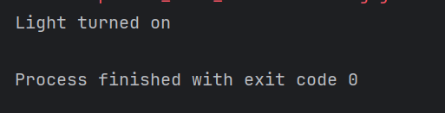
Task 09:

DIP implementation:

interface SwitchOnOff {
void turnOn();
void turnOff(); // void remoteControl();// void alexaVoiceControl();
}
class LightBulb {
void turnOn() {
sout("light turned on");
}
void turnOff() {
sout("light is off");
}
} // or class fan, class inverter, class washing machine...(in future remote for washing machine
// i can extend without modification..
class Switch { // switch is depending on switchonoff class not on light bulb..
SwitchOnOff device;
void Switch(SwitchOnOff device) {
this.device = device;
}
void operates() {
device.turnOn();
}
}
class DIP {
psvm(....){
SwitchOnOff lbulbobj = new LightBulb();
Switch lightswitch = new Switch(lbulbobj);
lightswitch.operate();
}
}
class LightBulb {
void turnOn() {
System.out.println("Light turned on");
}

void turnOff() {
System.out.println("Light is off");
}
}

// DIP Violation: Switcht2 directly depends on LightBulb
class Switcht2 {
LightBulb lbulbobj;

Switcht2(LightBulb lbulbobj) {
this.lbulbobj = lbulbobj;
}

void operate() {
lbulbobj.turnOn();
}

public static void main(String[] args) {
LightBulb lbulbobj = new LightBulb(); // tightly coupled
Switcht2 Switcht2Obj = new Switcht2(lbulbobj);
Switcht2Obj.operate();
}
}

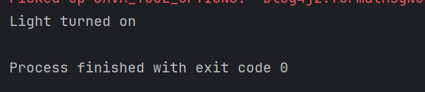

Task 10
Refer the below doc in Docs to study
Doc 07 UML Class Diagrams

Dependency
class Engine {
void start() {
System.out.println("Engine starting");
}
}

class Car {
void drive() {
Engine engine = new Engine(); // Dependency
engine.start();
System.out.println("Car is driving");
}
}

public class DependencyExample {
public static void main(String[] args) {
Car myCar = new Car();
myCar.drive();
}
}
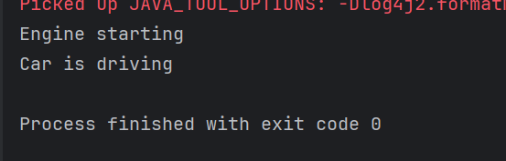

Task 11:

Aggregation
class Driver {
private String name;

public Driver(String name) {
this.name = name;
}

public String getName() {
return name;
}
}

class Car2 {
private Driver driver; // Aggregation

public Car2(Driver driver) {
this.driver = driver;
}

public Driver getDriver() {
return driver;
}
}

public class AggregationExample {
public static void main(String[] args) {
Driver driver = new Driver("John");
Car2 myCar2 = new Car2(driver);

System.out.println("Driver's name is " + myCar2.getDriver().getName());
}
}
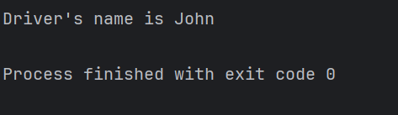

Task 12:

Composition
class Wheel {
public Wheel() {
System.out.println("Wheel created");
}
}

class Car3 {
private Wheel[] wheels;

public Car3() {
// Car3 creates and owns wheels
wheels = new Wheel[4];
for (int i = 0; i < wheels.length; i++) {
wheels[i] = new Wheel();
}
}
}

public class CompositionExample {
public static void main(String[] args) {
Car3 myCar3 = new Car3();

}
}
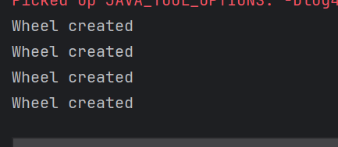

================================================================================================================================================

==============================================================

Info box:

=============================================================

https://excalidraw.com/#json=FvHREzZ_RxqrbO0_4iF3U,0WLjacoEfdym6RTsA9sGYA

Updated link: @ 11.00 26th July 2025 is the below one

https://excalidraw.com/#json=etbysGBZ-YBvF_bavIIil,E7NdpUtrmOPY-fn81ADwrg

Updated link: @ 12.32 26th July 2025 is the below one

https://excalidraw.com/#json=j65iMkcyw7xx05kC40oPT,KweCYuCM4owgVnjHoV4Llw

Generics

Wildcards characters

==============================================================

=============================================================

